Speeduino v0.4.3

Compatible with M52 PnP ecu

1. Getting started 2

1. Connecting to a car 2

2. Kytkeminen tietokoneeseen 2

1. USB-connection 2

2. Bluetooth connection 3

3. Connecting to TunerStudio 4

2. Configuring Speeduino before the first start 8

1. Required Fuel 8

2. Injector parameters 9

3. TPS Calibration: 10

4. Wideband calibration 10

5. Starting the engine 11

3. Tuning the engine 12

1. Idle control 12

2. Vanos 12

4. Connections 14

5. Firmware updates 14

# Getting started

## Connecting to a car

When connecting the ecu to the car, it is enough to plug it in to engine's wiring harness and run the MAP hose from intake to the MAP sensor connector at the back of the ecu. In addition, for tuning the ecu, run the 0-5v signal from wideband lambda controller to the external rear connector. See Section 4

## Kytkeminen tietokoneeseen

You can connect Speeduino to your computer / tablet / cellphone using USB or Bluetooth. Unfortunately, these cannot be used at the same time, and if you want to use USB instead of Bluetooth, then the Bluetooth module need to be removed from ecu. Of course, the Bluetooth connection works same way as the USB connection. The only difference is that if the firmware wants to upgrade it must be done with a USB cable.

NOTE! Rev 1.3 or higher PCB’s have diode D1 that allows USB to be used without need to unplug Bluetooth module.

### USB-connection

When connecting a USB cable to your computer, you need to install the appropriate drivers for your computer. Usually windows installs drivers automatically, but if the Arduino mega has the CH340 chip for USB, the windows drivers for that may cause connection failure, so it is recommended that you install the manufacturer's own drivers before connecting the USB hub. These can be found at<http://www.wch.cn/downloads/CH341SER_ZIP.html>

The page and the installer are partly in Chinese, but the installation should still be easy. Use a web page, for example, with a Chrome browser and put google translate to translate it into English.

After connecting the Speeduino to the computer with the USB, the USB Serial CH340 should be found under Device ports in Device Manager. If so, all ok and remember the COM port number.

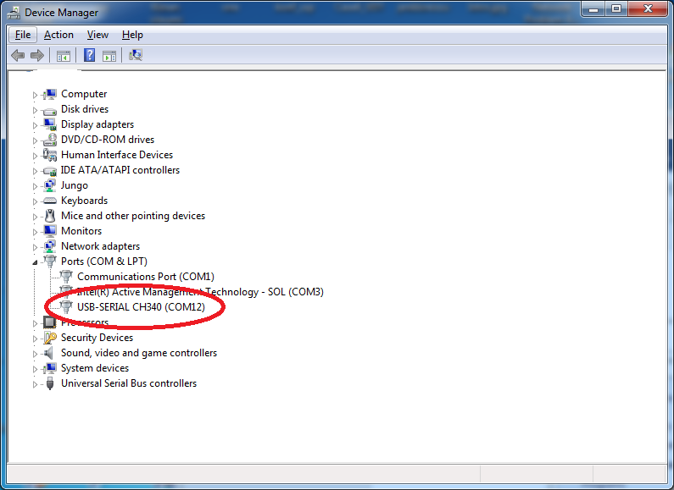

If the Arduino mega has ATMega16U2 or 8U2 instead of the CH340, the Automatic windows drivers work fine. Here is how you can tell which one you have by looking your Arduino Mega:

ATMega16U2 or 8U2:

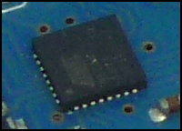

CH340:

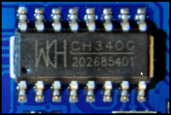

### Bluetooth connection

When connecting with Bluetooth, Speeduino must be in the car and the currents on. Then, with a computer / tablet / mobile phone, Bluetooth search for new devices. After a moment of search, it should find a Bluetooth device called SpeeduinoM52 (or what name you did gave for Bluetooth module if you did configure it by yourself). Connect to it.

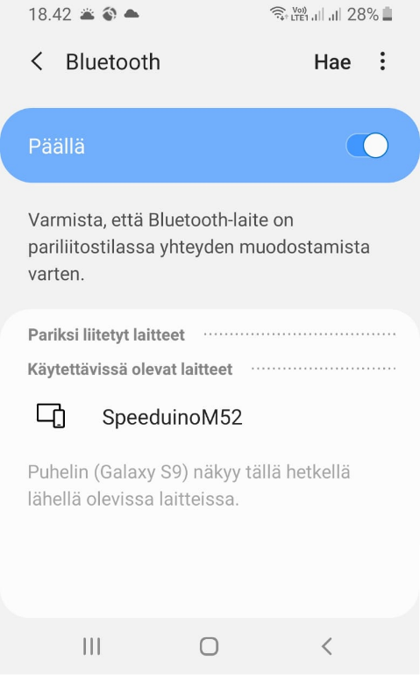

After that, Bluetooth should ask for the PIN code and if not ask for the PIN code for the use of the Bluetooth device. The PIN code can be found on the top of the box (if it has a Bluetooth module inside it) or the PIN number you did configure Bluetooth with, the Speeduino should be connected without problems. On the computer, then, the Device Port under COM ports should have a Bluetooth Serial COM port. Remember this COM port number.

### Connecting to TunerStudio

Tuning Speeduino happens using TunerStudio. If you don’t already have TS, it can be downloaded here: <http://www.tunerstudio.com/index.php/tuner-studio>

After opening TS, click: Create New Project

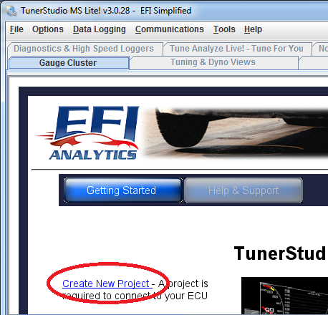

Give the project a name and click Detect. The Tuner Studio should automatically detect Speeduino and download configuration from the server.

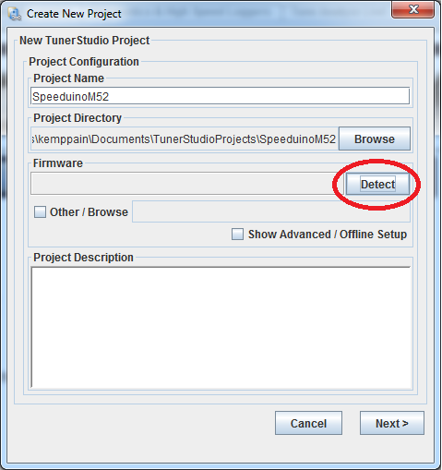

This requires an Internet connection from the machine when you try to connect Speeduino to your computer. If the Internet connection is not available or the authentication otherwise fails, the configuration must be added manually. The required files can be found in the Speeduinon firmware packages. The zip files for each Firmware release can be found from here: <https://github.com/noisymime/speeduino/releases>

Choose the zip package that corresponds your Firmware version and unpack it.

After that select: Other / Browse in TS where it says Firmware.

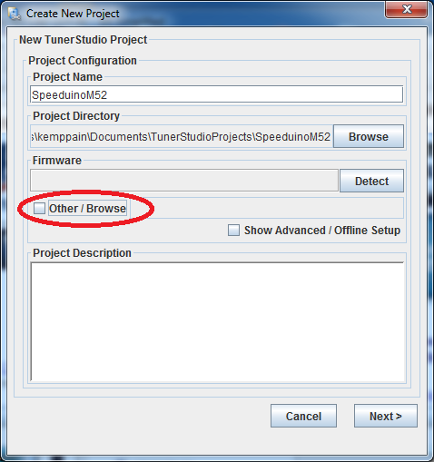

The downloaded and unpacked Firmware package contains a speeduino.ini -file under reference folder. Select it and click next. 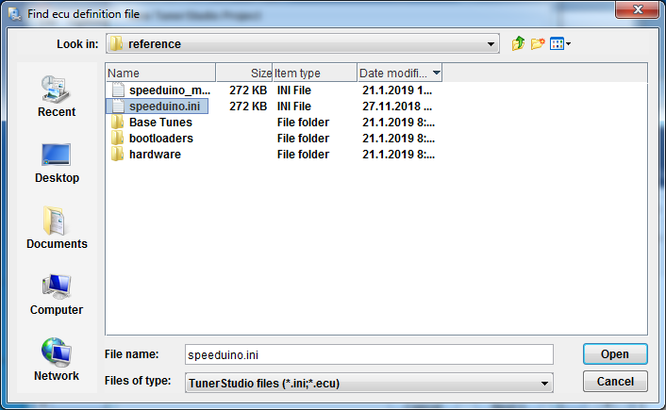

From the menu that opens, choose Temperature Displays as Celsius unless you want to see the temps in Fahrenheit. In this menu, you can also choose Fueling Algorithm as Alpha-N, but Speed ​​Density is usually used. From Enablehardware_test, you can unblock the injector / ignition output testing, but you probably wont not need it. Of course, if that is needed, you can also enable it later.

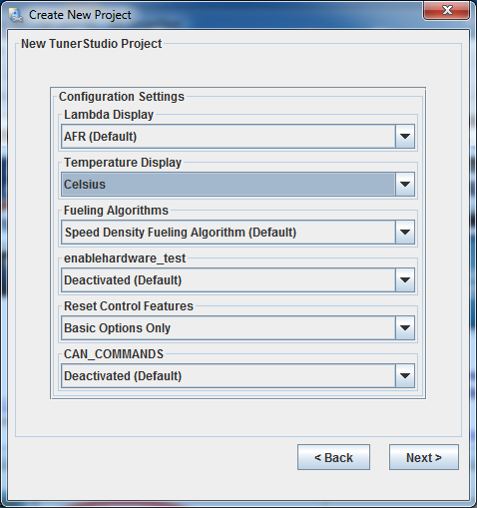

Klikkaa next.

For Com Port, select the port you saw in Device manager:

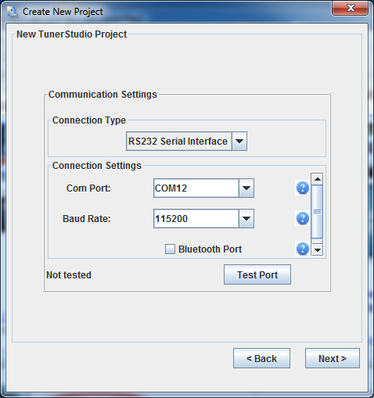

Click next and then to Finish to make TunerStudio connect to speeduino:

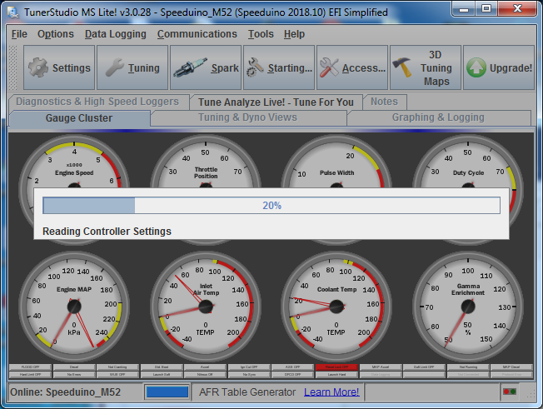

Check that the MAP sensor displays about 100kpa and the temperature sensors are sensible values ​​(with a cold engine both about the same ambient temperature). If you have built the ecu by yourself, you need to calibrate the temperature sensors first.

# Configuring Speeduino before the first start

## Required Fuel

Before the engine can be started for first time, the Speeduino must be configured for used setup in TunerStudio. Click on “Settings” and “Engine Constants”.

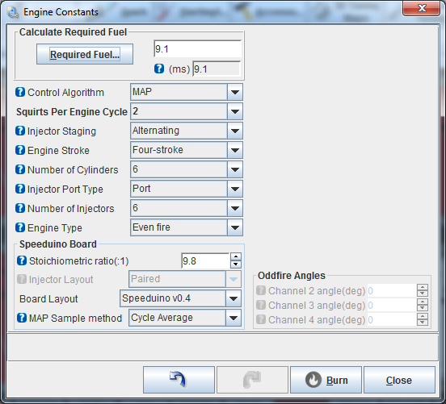

Everything here should be ok ready from Base Tune, but then click Required Fuel:

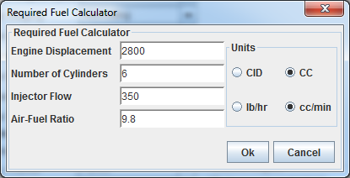

Engine Displacement = Set correct engine displacement. Remember to select correct unit.

Injector Flow = B28 pinks are about 215cc/min and the B20 / B25 greens are about 190cc/min. If some else injectors are used, you will need to use the provided injector data for setting flow rate. Note that the basic flow rate is often reported at 3bar base pressure, but m52 uses a 3.5bar base pressure.

Air-Fuel Ratio. = Stoichiometric mixture ratio. 14.7 for gas and 9.8 for e85.

Once set, click ok and TunerStudio will calculate ReqFuel value.

## Injector parameters

To set injector parameters go: Settings -> Injector Characteristics

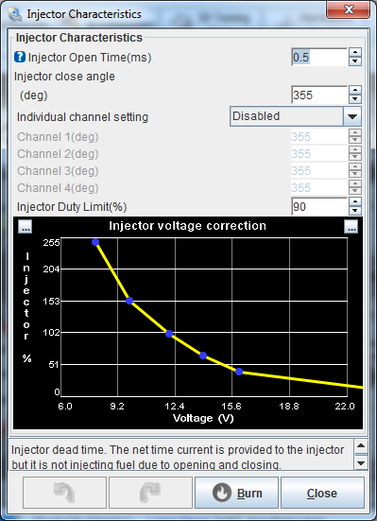

Injector Open Time is the same as dead time, latency, etc. This means you need to enter the dead time of the injectors and voltage correction. The values ​​for B20 / B25 greens are:

Open Time 0,5 ms

Voltage correction:

|  |  |  |  |  |  |  |
| --- | --- | --- | --- | --- | --- | --- |
| Voltage | 8 | 10 | 12 | 14 | 16 | 24 |
| % | 248 | 153 | 100 | 65 | 40 | 10 |

B28 pinks:

Open Time 0,6 ms

Voltage correction:

|  |  |  |  |  |  |  |
| --- | --- | --- | --- | --- | --- | --- |
| Voltage | 8 | 10 | 12 | 14 | 16 | 24 |
| % | 220 | 145 | 100 | 65 | 40 | 10 |

For other injectors, refer the injector datasheet.

## TPS Calibration:

To calibrate the throttle position sensor, go to Tools -> Calibrate TPS:

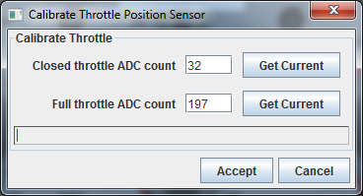

When you do not touch the gas pedal at all, press Get Current under Closed throttle. Then press the throttle down and Get Current at Full Throttle. Then, the Accept and TPS values ​​should now reasonably move between 0 and 100%.

## Wideband calibration

For wideband lambda calibration, you need to go to Tools -> Calibrate AFR sensor.

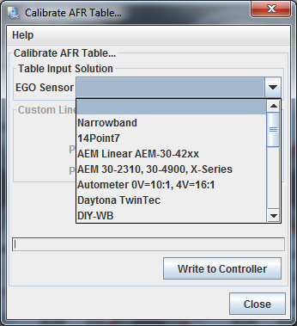

From the EGO sensor list, select the broadband controller you are using and click Write to Controller. If your wideband controller is not on the list, you should use either of the custom selections and manually enter the values ​​according to the manufacturer's specification.

Once the values ​​have been written, the AFR gauge can be displayed by clicking the right mouse over a unused gauge and searching for the “Air: Fuel Ratio” in sensor inputs menu.

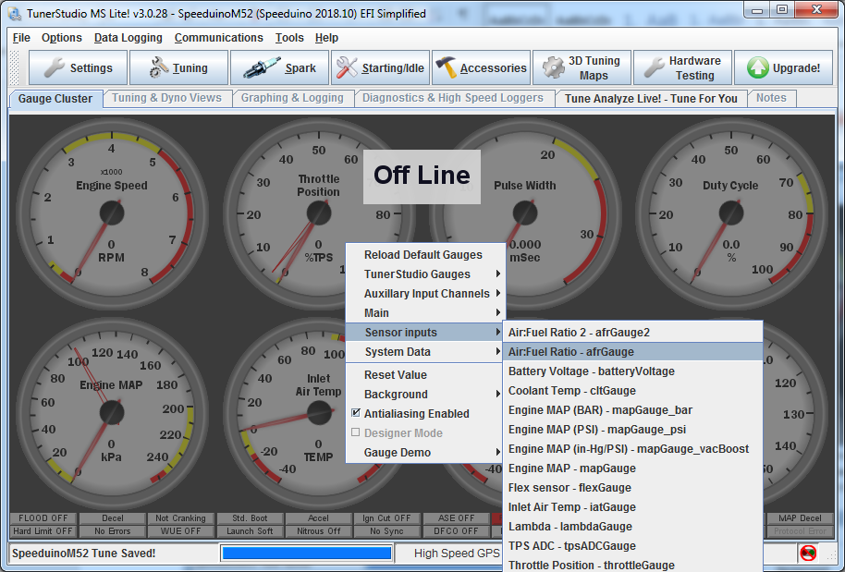

The gauge should now look like the display of the broadband controller itself (if any). If not, check the connections. The engine then ready to be started.

## Starting the engine

Once all the settings in the previous sections have been made, the engine should run. It should start at first crank, but if not, first try adjusting the bottom of the VE map up or down:

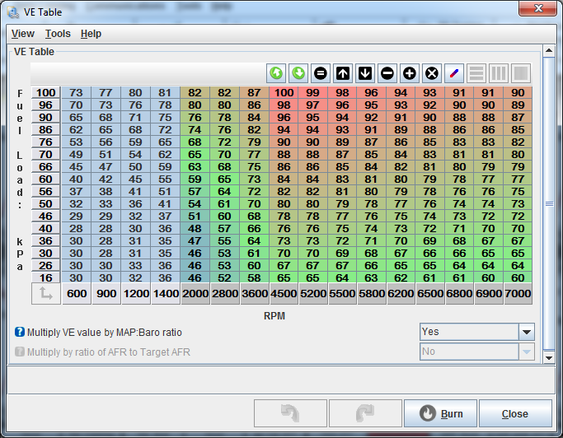

Once the engine is started, you can start tuning it. NOTE! Basic maps are just for the start. Before the car can be driver, Speeduino maps must be tuned to fit the engine.

# Tuning the engine

The tuning of the engine happens same way as with any other Aftermarket ecu. If you can tune Megasquirt with TunerStudio, you can also tune Speeduino. There is still A few noteworthy differences, like: Speeduino will not turn off when car ignition is off if the USB cord is attached to the Speeduino. Also, the Speeduino does not control anything other than the priming pulses or the fuel pump and injectors before the machine runs. Thus, the boost solenoid etc. cannot be tested if the engine is not running.

## Idle control

By default, idle control works in the Open loop mode, which can be changed to the Closed loop when the engine is otherwise tuned. In Open loop mode, idle rpms are adjusted from the “Idle - PWM Duty Cycle” -map. Cranking Duty is the idle valve map that is used during cranking, so if there is starting problems, tuning this map may help.

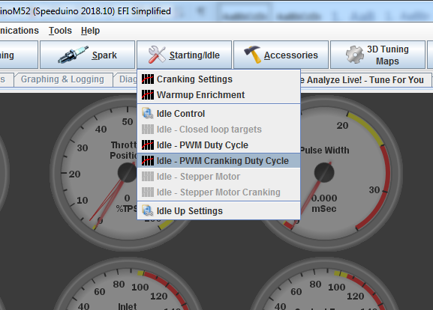

## Vanos

Vanos tuning can be done from “VVT duty” map from Accessories menu:

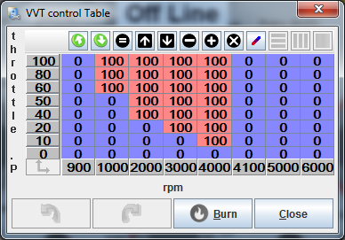

0% duty means that VANOS is off in the basic position and 100% duty means that it is on. Speeduino also allows PWM control, but the m52 vanos doesn’t work properly with open loop PWM control so use only 0% and 100% duty values.

# Connections

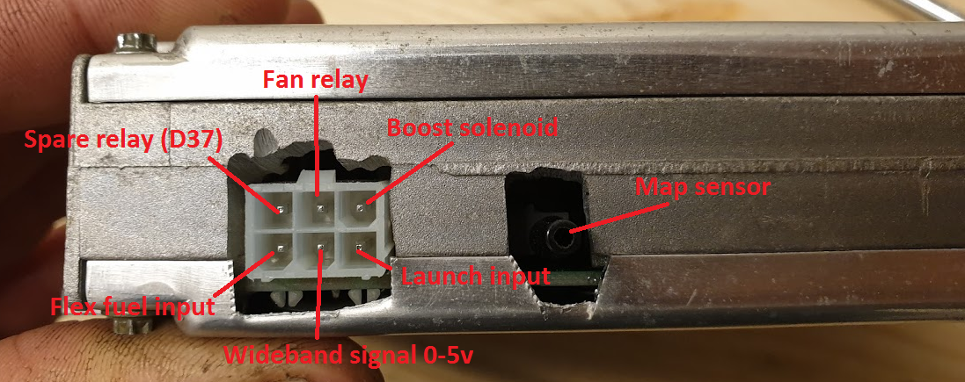

# Firmware updates

Speeduino is a continuously developing engine control unit, with new firmware updates released every few months, which include bug fixes and new features. You should keep track of what the new versions bring with you and upgrade your firm to the newer if the new features are available.

The most up-to-date instructions for updating firmware can be found at: <https://speeduino.com/wiki/index.php/Compiling_and_Installing_Firmware#Downloading_the_firmware>

NOTE! Before upgrading, take Speeduino out of the car, because if it is plugged in during the upgrade, the car may be horrible, such as coils may burn in the worst case. And after updating, review all the settings, maps, and calibrations that they are like before the upgrade.